Cheat Sheet 2 – SIEM Alerts
Title: Common SIEM Security Alerts – Causes and First Investigation Checks
Objective: To understand common security alerts, their possible causes and the first steps an SOC analyst should perform during investigation.

No. | SIEM Alert | Likely Cause | First Investigation Check
1 | Multiple Failed Logins | Brute-force attack or incorrect password | Check username, source IP and failed login count
2 | Successful Login After Failures | Possible account compromise | Check previous failed attempts and login source
3 | SSH Brute Force | Repeated SSH authentication attempts | Check /var/log/auth.log and source IP
4 | New User Account Created | Unauthorized account creation or admin activity | Check account name and Event ID 4720
5 | Suspicious PowerShell Execution | Malicious script or administrative activity | Check command line and parent process
6 | Nmap Port Scanning | Network reconnaissance or authorized scanning | Check source IP and destination ports
7 | File Integrity Change | File modification, deletion or unauthorized access | Check changed file, timestamp and user
8 | Suspicious Process Creation | Malware execution or unusual software activity | Check process name, path and parent process
9 | Privilege Escalation | User attempting to gain higher permissions | Check account privileges and related events
10 | Security Log Cleared | Possible attempt to hide activity or authorized maintenance | Check Windows Event ID 1102 and account
11 | Antivirus Detection | Malware or potentially unwanted software | Check detected file, threat name and action
12 | Unusual Login Location | Compromised credentials or VPN usage | Check source IP, location and login time
13 | Multiple Account Failures | Password spraying or authentication problems | Compare failed attempts across usernames
14 | New Service Installed | Legitimate software or persistence activity | Check Windows Event ID 7045 and service path
15 | Unusual Outbound Connection | Suspicious communication or legitimate application traffic | Check destination IP, port and process

Important Windows Event IDs
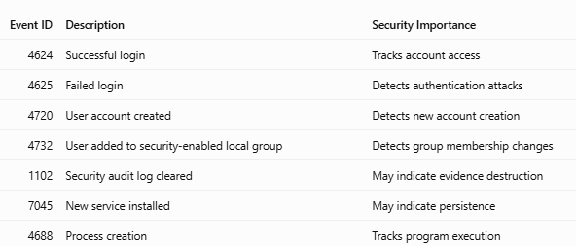

Basic SOC Alert Investigation Process
- Identify: Understand which alert was generated.
- Collect: Collect related logs and event details.
- Analyze: Check users, IP addresses, timestamps and processes.
- Classify: Mark the alert as True Positive or False Positive based on evidence.
- Respond: Escalate or recommend appropriate action.
- Document: Record findings and investigation results.

Conclusion
These cheat sheets provide quick references for common Splunk SPL commands and SIEM security alerts. They help SOC analysts perform log analysis, identify suspicious activities and investigate security incidents efficiently.

